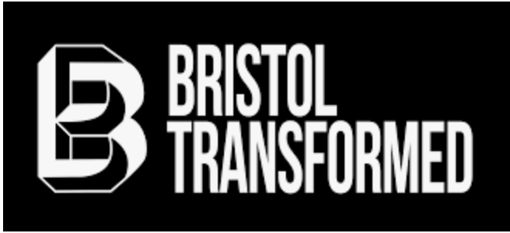

Bristol Transformed Bullying and Harrassment Policy
Purpose
The purpose of this policy is to make people aware of unacceptable behaviour and protect them from bullying and harassment when they are involved with Bristol Transformed.
Bullying and harassment
Bullying and harassment is behaviour that makes someone feel intimidated or offended. Harassment is unlawful under the Equality Act 2010.
Examples of bullying or harassing behaviour include:
spreading malicious rumours
unfair treatment
picking on or regularly undermining someone
denying someone’s training or development opportunities

Bullying and harassment can happen:
face-to-face
by letter
by email
by phone
The law

Bullying itself is not against the law, but harassment is. This is when the unwanted behaviour is related to one of the following:
age
sex
disability
gender reassignment
marriage and civil partnership
pregnancy and maternity
race
religion or belief
sexual orientation

What Bristol Transformed volunteers or members should do if they’re bullied or harassed
Volunteers or members should see if they can sort out the problem informally first. If they cannot, they should talk to the Bristol Transformed Safeguarding and Whistleblowing Rep
The current Bristol Transformed Safeguarding & Whistleblowing Rep is Toni Mayo who can be contacted via whistleblowing@bristoltransformed.co.uk.
If there is any reason why you don’t feel comfortable contacting the nominated rep you can contact another committee member directly via their personal email. These contacts are Paul Tasman (paultasman@gmail.com), Louise Delmelge (louisejdelmege@gmail.com) or Kieran Glasssmith (kieran.glasss@gmail.com).

This policy was last reviewed on 28th March 2023

