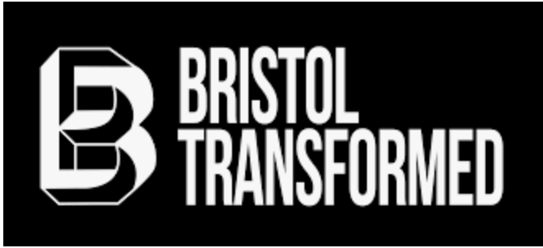

CODE OF CONDUCT

Welcome to Bristol Transformed 2023. People come to Bristol Transformed from lots of different walks of life, with different histories and knowledge. It’s important that everyone feels able to contribute if they wish - whether it’s your first political event or your hundredth - and that everyone’s contributions are taken seriously. This is a pluralist space in which we encourage comradely debate, but bigotry of any kind will be challenged. We are all here to learn - both from the speakers, and from each other - and we must be kind to each other as we do so.

We recognise that a positive and inclusive environment is both a beautiful and fiercely effective tool for social engagement and political struggle. With this in mind we agree to the following principles of action:

- We expect everyone - be they speaker, volunteer, participant, or other - to treat each other with respect, understanding, and decency.
- We approach each other with a caring and considerate attitude.
- We look after one another.
- We value each and every person’s contribution to Bristol Transformed equally, however large or small.
- We recognise that each and every person who contributes both belongs to, and is an equal member of, Bristol Transformed.
- We share information, skills and knowledge with each other freely and transparently.
- We work together to ensure that power does not become concentrated in any person(s) or post(s) within Bristol Transformed.
- We do not tolerate behaviour or language which is discriminatory, aggressive, abusive, or constitutes harassment.

Bristol Transformed reserves the right to remove or refuse entry to anyone who does not follow the above Code of Conduct. Workshop leaders and panel chairs are encouraged to respectfully challenge anyone who does not follow the Code of Conduct. Decisions on breaches of the code of conduct are at full discretion of the organisers.

