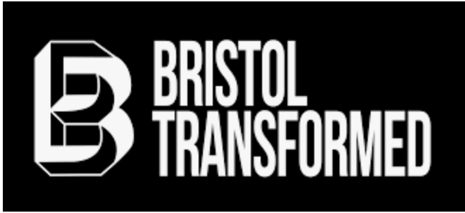

Bristol Transformed Privacy Policy
This privacy policy outlines the processes Bristol Transformed follows when storing and handling personal data. Bristol Transformed is a private limited company by guarantee, company number 12078494.
The data controller is Bristol Transformed of 6 Ashgrove Road, Bristol, BS79LQ, Bristol Transformed can be contacted at that address, on bristoltransformed@gmail.com.
This policy is regularly reviewed. The last review took place on 28th March 2023.
Data types collected
Bristol Transformed collects names and contact details (such as email and postal addresses and phone numbers) for the purpose of our mailing list and ticketing system.
We also store information on whether or not you are a Patreon supporter and information on how much, when and how often you have donated.
Mailing list
All subscribers to our mailing list have explicitly opted in and consented to receive Bristol Transformed’s email newsletter, which includes updates about our latest projects and events. The GDPR lawful basis for this data processing is consent.
We send emails using email service Mailchimp. Mailchimp’s role is limited to providing software to create and send emails, storage of our email list and consent records, and offering list subscribe and unsubscribe facilities. We have entered into a data processing agreement with Mailchimp to this end.
We will retain this data for as long as you remain subscribed to the list. You can opt out from our email list at any time. Every email includes a link to unsubscribe from the list.
Tickets
We sell tickets using ticket service Headfirst. Headfirst’s role is limited to providing software to create and sell tickets, storage of our ticket buyers list and consent records. We have entered into a data processing agreement with Headfirst to this end.
Bristol Transformed will use the contact details of ticket-holders to periodically send them relevant information about the event for which they have tickets, such as accessibility information, the programme timetable, or last minute schedule or venue changes.
Patreon Supporters
When you sign up to join our Patreon and pay a monthly donation, Bristol Transformed will save your contact details for the purposes of sending you our Supporters Newsletter, your free tickets, and information about other special offers and Patreon exclusive events. The GDPR lawful basis for this data processing is consent.
Bristol Transformed will also process this data from time to time with information relevant to your subscription, for example if you wish to cancel your donation or if you notify us of a change of your address.
Your data is stored securely on third-party servers operated by MailChimp, Headfirst, Patreon and Google.
We will retain this data for as long as you remain a member of our Patreon. We delete the data of lapsed subscribers one year after the date their subscription ends. This period is to allow for re-subscription reminder notices.
Payment data
Bristol Transformed does not see or store any sensitive payment information such as credit card details. Before we get access to our payments log, card details are removed from it by our payments service providers.
Data necessary to process credit and debit card payments is held by our card payment processor Izettle.
International Transfers
We are based in the United Kingdom and primarily collect and process data in the UK.
However, we do use third party processors who process data on our behalf and are based in the United States. The US is one of the territories outside the European Union whose laws are currently not considered to meet the same legal standards of protection for Personal Data as set out under Data Protection Law in Europe.
The US based third parties we use are Mailchimp (who handle supporter emails on our behalf) and Izettle (Who handle card payments on our behalf). Both are currently certified under the EU-U.S. Privacy Shield Framework which means that they are regarded as meeting the standards for protection of personal data that comply with Data Protection Law.
For more information see:
https://mailchimp.com/legal/privacy/
https://www.izettle.com/gb/privacy-policy
https://www.headfirstbristol.co.uk/privacy-policy
How we process your data
Your data is never shared with any third party. Access to your data is limited to Bristol Transformed staff and volunteers.
Making requests about your data
To request access to all the data Bristol Transformed holds about you (a subject access request) or request an export in a standard format (data portability), email bristoltransformed@gmail.com.
To request deletion of some or all the data Bristol Transformed holds about you (right to removal), rectify an error in it or request restrictions on our processing of it, email Bristoltransformed@gmail.com.
You have a right to ask Bristol Transformed to rectify any of your data, restrict the way in which we process it, object to our processing of it and the right to withdraw your consent to our processing of it. To exercise any of these rights, email bristoltransformed@gmail.com.
Complaints
If you have a complaint about this policy or any privacy issue, please do contact us in the first instance on bristoltransformed@gmail.com.
You also have a right to complain to the UK Information Commissioner’s Office (ICO) at ico.org.uk or Information Commissioner’s Office, Wycliffe House, Wilmslow SK9 5AF.

